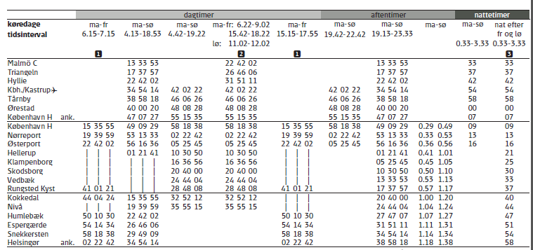
Your connection is between Kbh./Kastrup (or København H if you are staying in Copenhagen overnight) and Humlebæk.

